
National Teacher College
School of Arts, Sciences, And Technology
629 J. Nepomuceno Street, Quiapo, Manila, Philippines
Bachelor of Science in Information Technology
AY 2025-2026

By:
Alberto, Kenji
Combes, Clarence Izaac
Torrecampo, Rodel II
Pomarejos, Rob Thomas
Pauli, Richmond

Mobile-Based Camera-Assisted Remote Physical Therapy Monitoring System with Real-Time Pose Estimation and Compliance Tracking
Project Title

Mobile-Based Camera-Assisted Remote Physical Therapy Monitoring System with Real-Time Pose Estimation and Compliance Tracking

A Capstone Project
presented to the Faculty of the
School of Arts, Science and Technology
National Teachers College
Quiapo, Manila

In Partial Fulfillment of the
Requirements for the Degree of
Bachelor of Science in Information Technology

By:
Alberto, Kenji
Combes, Clarence Izaac
Torrecampo, Rodel II
Pomarejos, Rob Thomas
Pauli, Richmond

May 2026
ACKNOWLEDGMENT
The researchers would like to express their sincere acknowledgements towards everyone present who gave their utmost efforts of support towards the completion of this capstone project. All this would not have been possible without the combined efforts of all throughout the research and development of the project in question.

First and foremost, the deepest gratitude towards our God, The Lord Almighty, for giving us the light, strength and guidance that is needed to complete this capstone project.

Secondly, is the acknowledgement of gratitude towards our capstone project adviser. Mr. Kenner B. Rondilla, for his guidance in our steps, the constructive criticism with the development of the development of the Mobile-Based Camera-Assisted Remote Physical Therapy Monitoring System with Real-Time Pose Estimation and Compliance Tracking

Thirdly, the researchers would extend their thanks to The National Teachers College, especially the Soast Department for providing us with the environment and necessary resources present for this study.

Lastly, the researchers thanks all of the respondents and Rehab Plus Physiotherapy who provided the means and the feedback during the creation of this study. The vitals provided were the necessary part for the function of the title. And finally, we thank our family and friends for the unwavering moral and emotional support during the journey.

ABSTRACT
The study developed a “Mobile-Based Camera-Assisted Remote Physical Therapy Monitoring System” for Rehab Plus Physiotherapy that aims to improve home-based rehabilitation monitoring through the integration of artificial intelligence, mobile computing, and web technologies. The primary objective of the system is to assist physical therapy patients in performing prescribed rehabilitation exercises accurately while allowing therapists to remotely monitor patient progress and compliance. The proposed system addresses common challenges in traditional home rehabilitation, such as lack of supervision, inaccurate exercise execution, inconsistent patient compliance, and limited objective monitoring outside the clinical setting. The system features include: (a) AI-powered pose estimation using the MediaPipe framework, (b) real-time body landmark and joint angle detection, (c) automated repetition validation, (d) real-time visual and auditory corrective feedback, (e) patient compliance and pain-level monitoring, and (f) a web-based dashboard for therapists and administrators to monitor rehabilitation progress and exercise performance remotely. Through these features, the system provides a more accessible and technology-driven approach to rehabilitation monitoring while reducing the need for frequent clinic visits.
The system was developed using the Flutter framework and Dart programming language for the Android-based mobile application, React.js and Laravel for the web-based clinical dashboard, Firebase and Google Cloud Firestore for real-time synchronization, MySQL for structured data storage, and RESTful APIs for secure communication between system platforms. The study utilized the MediaPipe framework to implement real-time pose estimation and movement analysis through smartphone camera input without requiring additional wearable devices or specialized hardware. The developed system will be evaluated using selected ISO software quality and usability standards to determine its functionality, usability, reliability, and effectiveness as a telerehabilitation monitoring solution. The results of the study are expected to demonstrate the potential of integrating artificial intelligence and mobile health technologies in improving rehabilitation accessibility, exercise accuracy, and remote patient monitoring for physical therapy services

TABLE OF CONTENTS
CHAPTER I: INTRODUCTION
Project Purpose
Project Description
Objectives of the Study
General Objective
Specific Objectives
Significance of the Study
Scope and Limitation of the Study
Scope
Limitation
Review of Related Literature
Technical Background
Conceptual Framework
Definition of Terms
Chapter II. Methodology
Design of Software , System, Product or Process
Data Flow Diagram
Software Development Life Cycle
System Flowchart
Entity Relationship Diagram
Use Case Diagram
Requirements Analysis: Software, Hardware, and System Specifications
Requirements Documentation
Development and Pre-Testing procedures
Implementation Plan (Infrastructure/ Deployment
Statistical Treatment of data
Data Gathering Technique
Setting of the Study
Subject of the Study
Sampling Technique
Statistical Treatment of Data

CHAPTER I
INTRODUCTION
Physical rehabilitation is a significant process in which a patient recovers from painful injuries to muscles, post-surgical conditions, or other muscle disorders. Typically, rehabilitation is provided in rehabilitation centers, where therapy is conducted under state-licensed physical therapists. Many patients note that regular therapy sessions are hard to attend due to costs, heavy traffic, restricted mobility, long distances, and uncomfortable schedules. In such cases, patients may be advised to perform physical exercises at home, thereby creating an avenue for improper execution.
expanding healthcare's potential approach to patient care with the latest in technological innovations, telerehabilitation, for instance, incorporates virtual independence while being remotely guided by an equivalent to engage in therapeutic physical exercise. Recently developed technologies such as computer vision and pose estimation have made it possible to analyze body movements using only a smartphone, which eliminates the need for costly and elaborate setups. This creates rather a handful of opportunities for developing fully monitoring intelligent rehabilitation systems that can provide corrective feedback on how to perform the exercises.
Patients from rural areas have difficulty accessing rehabilitation services in the Philippines. Alongside the above-mentioned problems, currently adopted monitoring techniques mostly rely on the reports of the patients, which may not be entirely valid or accurate. Therefore, there is a dire need for technology-assisted solutions that could help optimize rehabilitation processes outside the clinic.
For that reason, the proponents have developed a Mobile-Based Camera-Assisted Remote Physical Therapy Monitoring System for Rehab Plus Physiotherapy. The system uses the pose estimation feature of MediaPipe to evaluate body movement and validate exercises in real time using the patients' smartphones. The system has two major components: an Android application for the patients and a web UI for physiotherapists and personnel in charge of clinics. Features such as real-time corrective feedback, automatic validation of exercises, and comprehensive monitoring will lead to better patient compliance, enhanced recovery, and less frequent visits required at the clinic.

1.0 Project Purpose
This project intends to reduce the chasm between clinical physical therapy and home-based rehabilitation by providing solutions for two key challenges: patient non-compliance and insufficient professional input during the course of prescribed exercise programs. The proposed, mobile, camera-assisted remote physical therapy monitoring system will be based on real-time pose estimation technology to provide an AI-driven, indicative feedback for the patient while performing rehabilitation exercises at home.

To further supplement this, service providers at Rehab Plus Physiotherapist will have a system in which a centralized, data-rich monitoring dashboard for meaningful and reliable transformation of patients' self-reports into valid and verifiable information underpins their service.

With the means for exercise validation, compliance tracking, and remote monitoring all built into one system, it is believed that rehabilitation in the study will be more accurately conducted, will obtain better recovery outcomes, and lessen burdens arising from transportation and mobility while guaranteeing equally uninterrupted access to physical therapy services, regardless of the patients' locations.

1.1 Project Description
The Mobile-Based Camera-Assisted Remote Physical Therapy Monitoring System is a telerehabilitation system designed to fill the gap between clinical physical therapy and home rehabilitation. It sets out to enhance both the quality and consistency of rehabilitation exercises by replacing the conventional home exercise program with an intelligent, reliable, AI-assisted monitoring platform, offering real-time guidance, movement validation, and objective performance tracking.
The proposed system will incorporate smartphone camera technology with real-time pose estimation in body movement analysis and exercise execution assessment based on movement requirements defined by the therapist. Such an automated monitoring and feedback system will allow patients to actually perform prescribed rehabilitation exercises at home, with the possibility of the therapist continuously monitoring patients' progress and achievements outside the clinic.
The system provides the following core functionalities:

Real-Time Pose Estimation
Advanced computer vision and pose estimation methods will identify body landmarks and compute joint angles for rehabilitation exercises. Consequently, movements and their data can be stable and reliable when patients are assessed with a smartphone camera.

Automated Compliance and Accuracy Tracking
In addition, it will also be capable of informing the therapist whenever a patient has practiced an exercise outside of the advised time for unassisted practice. The collected data will consist of repetition counts, correct execution, and compliance with reports.

Immediate Corrective Feedback
Corrective cues and guidance, in real time, will be given by the mobile application so that patients may continue to make adjustments whenever any movement is performed inaccurately during exercise sessions, thereby minimizing the possibility of a poorly performed rehabilitation program.

Web-Based Clinical Dashboard
This includes an easy-to-use centralized web-based dashboard through which the PT can remotely access the patient's exercise logs, compliance rates, recovery progression, and pain reports.

Target Users and Beneficiaries:

Primary Users
The primary users or targets of this system include physical rehabilitation patients, particularly those with mobility issues or transportation problems, or even those located in rural areas who are in need of constant surveillance during their rehabilitation period.

Secondary Users
Secondary beneficiaries include physical therapists and rehabilitation clinics such as Rehab Plus Physiotherapy, which is interested in the area of increasing rehabilitation monitoring and patient compliance and extending the provision of healthcare beyond in-clinic appointments.

Technology Stack
The proposed system includes an Android mobile application and a web-based management platform. It uses the MediaPipe framework in the application for real-time pose estimation and body landmark detection. Processing of edge-based movements is done using mobile computing, whereas cloud-based synchronization allows real-time data exchange between patients and healthcare providers.
The proposed system comprises an Android-based mobile application integrated with a web-based management platform. The application uses the MediaPipe framework for real-time pose estimation and body landmark detection. In this regard, mobile computing has been employed in edge-based movement processing, whereas cloud-based synchronization allows real-time data exchange between patients and health care providers.

1.2 Objectives of the Study
This study focuses on developing a camera-enabled mobile monitoring system of remote physical therapy that applies real-time pose estimation in validating rehabilitation exercises, monitoring patient compliance, and remotely managing rehabilitation at Rehab Plus Physiotherapy.
1.2.1 General Objectives of the Study
The system will be designed and developed to provide, through the integration of real-time pose estimation technology, a mobile solution that allows patients to conduct rehabilitation exercises independently while providing a close view of the particulars of exercise execution, adherence, and recovery progress by the therapist.

1.2.2 Specific Objectives of the Study
- To identify the rehabilitation exercises, movement parameters, joint angle thresholds, and repetition requirements required by Rehab Plus Physiotherapy for remote exercise monitoring.
- To design a system architecture that will include both a mobile application for the identification of the patients' poses and a web dashboard for therapists to monitor and visualize the data.
- To develop a real-time pose estimation module using the MediaPipe framework for detecting body landmarks and calculating joint angles during rehabilitation exercises.
- To implement an automated exercise validation and repetition tracking mechanism based on therapist prescribed body movement requirements.
- To develop a real-time corrective feedback system that assists patients in properly performing prescribed rehabilitation exercises.
- To implement a centralized data logging and monitoring module capable of tracking patient compliance, exercise accuracy, session history, and reported pain levels.
- To evaluate the functionality, usability, and accuracy of the system through pilot testing with selected patients and therapists of Rehab Plus Physiotherapy.
- To assess the effectiveness of the system in supporting remote rehabilitation and reducing unnecessary clinic visits for patients with mobility or transportation limitations.
1.3 Significance of the Study
The development of the Mobile-Based Camera-Assisted Remote Physical Therapy Monitoring System is expected to provide significant benefits to the following stakeholders:
Patients (End Users)
The system will empower patients with a safer, more accessible, and user-friendly method of home rehabilitation. Without a clinic visit, patients can adequately perform the prescribed rehabilitation exercises with real-time corrective feedback and automated monitoring. This lessens the burden of transportation and other mobility issues that patients may face while ensuring that rehabilitation and recovery processes continue to progress.
Physical Therapists (Client)
What follows is a system that will allow physical therapists continuously to support reliable and data-driven monitoring tools to track patients' progress through rehabilitation. Rather than solely relying on the sometimes unreliable self-reporting of patients, therapists can verify and validate the performance of exercises, monitor patient compliance rates, and assess movement quality to review progress through a central monitoring dashboard.
Rehab Plus Physiotherapy (The Organization)
Extending beyond previously clinic-based session monitoring, the proposed system would help Rehab Plus Physiotherapy, in turn enhancing service effectiveness, by supporting patients in prescribed treatment plans, optimizing therapists' workloads, and ultimately facilitating access to rehabilitation services for clients in rural areas.

The Proponents
This study will provide the proponents with the application of the knowledge and technical skills acquired in computer vision, mobile applications, pose estimation, cloud computing, and healthcare IT. They will gain additional experience in building AI systems that target specific challenges in healthcare.

The School/Institution
This will somehow contribute to the university’s repository regarding creative information technology research.
The Community
This research supports the integration of smartphone-based digital health technologies into rehabilitation. Such technologies would streamline the rehabilitation process and lessen the burden on healthcare facilities and patients needing extensive therapy services.

Future Researchers
This report will be of tremendous importance during subsequent work referring to areas that range from telerehabilitation, pose estimation, and computer vision to artificial intelligence and human-computer interaction. Thus, information here can be developed into new tools in rehabilitation monitoring or extend current systems within healthcare.

1.4 Scope and Limitation of the Study
1.4.1 Scope
The main focus of this project is the design and development of a camera-integrated mobile remote monitoring system in physiotherapy for Rehab Plus. The study wants to improve and support remote rehabilitation through the real-time pose. The main scope of this project is to:

Technology Platform
The proposed system will consists of 2 primary components:
- mobile application for patients
- web-based dashboard for physical therapists
The system is designed with a client-server architecture utilizing cloud-based data synchronization for remote monitoring and centralized data management.

Core Functionalities

AI-Based Movement Analysis
The system utilizes the MediaPipe framework for real-time pose estimation, body landmark detection, and joint angle calculation during rehabilitation exercises.

Repetition Validation
This system will record and validate repetitions only once the patient's movements satisfy the criteria and angles set forth by the therapist.

Real-Time Corrective Feedback
During the rehabilitation session, visual feedback and auditory corrective cues will be given through a mobile application to ensure the patient's own progress and improvement in the exercises.

Clinical Monitoring Dashboard
The web-based dashboard enables the therapist to remotely check on the patients' compliance with exercises, the correctness of the exercises, reported pain, and general progress in rehabilitation.

Target Users:

Patients
The subjects in this study will be patients who have been recently referred to Rehab Plus Physiotherapy for rehabilitation of an upper or lower limb condition and who have recently had their initial assessment completed.

Physical Therapists
Similarly, this system will be used by licensed physical therapists who supervise the prescription of rehabilitation exercises and the remote monitoring of recovering patients.

Exercise Coverage
This system will be able to cover the orthopedic rehabilitation exercises of knee extension, elbow flexion, and shoulder abduction. It does not include general fitness exercises or analysis using video input for unrestricted body movement.

1.4.2 Limitations
A Mobile-Based Camera-Assisted Remote Physical Therapy Monitoring System is proposed in this project for development purposes and is exclusively intended for rehabilitation monitoring and support at Rehab Plus Physiotherapy. It is restricted only to those who have undergone an initial in-person assessment and evaluation by a licensed physical therapist. Further, the proposed system will not conduct any diagnostic medical assessment or treatment prescribing. The mobile application is developed for Android smartphones; therefore, it is not compatible with iOS devices or any other desktop platform.
This capstone project has limitations for the following users:
- Physical Therapists/Administrators – The online dashboard allows therapists and administrators to manage all exercises, monitor patient progress, and review rehabilitation records. It does not, however, provide any automatic facilities with regard to medical diagnosis, treatment recommendations, billing, payroll, or appointment scheduling.
- Patients – Patients are permitted only to carry out the rehabilitation exercises prescribed by their respective therapists. The system relies solely on the smartphone's built-in camera for pose estimation and movement analysis. Some exercises may be adversely affected by environmental factors, such as poor connectivity or the wearing of loose-fitting clothing that would interfere with the body landmark detector.
- Non-Registered Users – This system is only to be used by persons who are registered with Rehab Plus Physiotherapy and who have been authorized by its therapists.
Data collection and monitoring is limited to a selection of common orthopedic rehabilitation exercises, namely, upper and lower limb movements. The system does not provide support for high complexity, high-speed, or full-body athletic movements, which exceed the boundaries of mobile-based pose estimation technology. Performance and usability will be assessed against selected ISO software quality and usability standards.

1.5 Review of Related Literature
1.5.1 Foreign Literature
Computer Vision and Real-Time Pose Estimation
Human pose estimation has developed from complex sensor-based systems into simple, elegant, robust, and easily deployable camera-based systems. In this direction, State-of-the-Art Computer Vision researchers Zhe Cao et al. in 2019 brought about OpenPose. The real-time multi-person 2D pose estimation framework defines part affinity fields conceptually for a high-performance, accurate detection and tracking of human body movements. This system is effective but highly resource demanding, which involves problems regarding portability toward mobile-based applications.
On the contrary, Camillo Lugaresi et al. 2019 proposed MediaPipe as an alternative by robustly packing lightweight and efficient pose estimation upon mobile devices without any dependency upon dedicated hardware. MediaPipe provides accurate body landmark detection and joint angle computation with standard off-the-shelf smartphone cameras, making it suitable for tele-rehabilitation.
Further, Yilun Chen et al. 2017 proposed Adversarial PoseNet, which is a neural network exponentiation development mechanism that generates biologically plausible human pose estimations. The methodology makes a contribution to reassuring movement analysis and mitigates wrong joint angle interpretations caused by inconsistencies in the environment or camera.
Biofeedback mechanisms will be fundamental in capturing the improvements made by patients inside rehab systems. As Owen M. Giggins et al. (2013) describe, visual and auditory biofeedback increases the patients' motivation and aids the correction of movements performed during rehabilitation exercises, making them more precise and leading to better treatment results.

On Telerehabilitation and Clinical Outcomes
Telerehabilitation has been well conceptualized and recognized for its relative effectiveness over conventional clinical rehabilitation service. It is noted by Laver et al. 2016 that remote clinical services can achieve clinical outcomes equivalent to those derived from face-to-face consultations in both cases of stroke and orthopedic rehabilitation patients.
Michel Tousignant et al. (2011) also demonstrated that home-based telerehabilitation following knee arthroplasty was able to achieve an increase in satisfaction and physical recovery while decreasing the burden of frequent clinic visits.
Motivational engagement is another important constituent of effective rehabilitation. According to Elias Flores et al. (2008), digital and interactive rehabilitation systems enhance patient adherence by making home exercises less monotonous and more fun.
Recently, the World Health Organization (2021), through its initiative Rehabilitation 2030, identified digital technologies for rehabilitation as one of the core components in responding to the increasing need for rehabilitation worldwide. Likewise, the United Nations 2015 report underscores that one of the important actions to achieving Sustainable Development Goal number three, which is about ensuring healthy lives and promoting the well-being of all, is technology-oriented health care solutions.

1.5.2 Local Literature
Adoption of Digital Health Technologies in the Philippines
There is still limited access to rehabilitation services in the healthcare system of the Philippines, mainly due to the lack of certified physical therapists outside the major metropolitan areas like Metro Manila. According to the Pew Research Center (2021), the Philippines is one of the countries in Southeast Asia with the highest rates of smartphone use.

Several studies have pointed out various barriers to accessing rehabilitation services in the Philippines, particularly those related to financial costs, traffic conditions, and clinic availability. The eHealth Strategic Framework, issued by the Department of Health of the Philippines, espouses this technology in pursuit of accessible healthcare.

Compliance Monitoring and Rehabilitation Challenges
Paper journals suffer from the pitfalls of recall bias and significant errors in the patient's records. Moreover, rehabilitation logging is sporadic among patients, making it burdensome for therapists to assess accurately both exercise compliance and progress in rehabilitation.
Among the other findings of local telerehabilitation studies that have Filipino participants is the promising effectiveness of real-time audiovisual feedback in improving the accuracy of exercise in performing and maintaining the engagement of patients in home-based rehabilitation exercises. A lack of proper guidance and timely feedback is coupled with improper execution of the exercises, leading to injuries in the case of the elderly and postoperative patients.
The surging volume of orthopedic rehabilitation cases in the Philippines is strong evidence of the increased demand for data-driven, technology-assisted rehabilitation monitoring that can enable remote patient supervision and improve the accessibility of rehabilitation services.

1.6 Review of Related Studies
1.6.1 Foreign Related Studies
Automated Motion Tracking and Exercise Validation
Several researchers around the globe have explored applications of pose estimation for rehabilitation assessment and validation of exercises. Hidalgo et al., from Germany, reviewed a model of full-body pose estimation for clinical motion analysis. Their review found that landmark detection in 2D on the body was capable using cutting-edge GPU technology but extremely demanding in terms of processing power and thus unsuitable for mobile applications.
Much of the recent work using MediaPipe has underscored the feasibility of integrating smartphone cameras to do real-time posture correction and exercise monitoring. Until now, such implementations have remained within the mainstream domains of fitness and well-being. By contrast, the work at hand develops a specific system for orthopedic rehabilitation exercises, in which the recovery progress is monitored by a therapist.
Additionally, Kulkarni et al. (2021) designed an AI-based posture correction system that verifies the completion of exercise repetitions based on defined movement thresholds. They discussed how automation in repetition counting ensures better consistency in exercises and eliminates improper execution. The present study proposes and recommends the use of a web-based therapist dashboard.

Feedback Systems and Patient Compliance
Several related studies have emphasized that feedback systems are an important element not only for improving rehabilitation outcomes but also for increasing patients' compliance with the prescribed therapies. Various rehabilitation systems already in place that incorporate visual and auditory feedback mechanisms have, to some extent, impacts on patient adherence and the correct execution of rehabilitation exercises during home-based therapies.
Gamified telerehabilitation platform researchers have thus shown that features such as progress and compliance tracking increase patient engagement in monotonous exercise. However, most state-of-the-art systems consider only patient engagement and do not incorporate movement validation automation.
Other rehabilitation studies can be cited that involve the use of wearable and measurement devices for remotely monitoring movements. However, such implementations have disadvantages regarding extra hardware and implementation costs. The present study is, therefore, device-free and relies purely on the patient's smartphone.
Most of the work done so far in rehabilitation systems has concentrated on fine motor movement rehabilitation. The proposed work, however, will provide support for upper and lower limb orthopedic rehabilitation exercises, including automatic exercise verification and therapist monitoring functionality.

1.6.2 Local Related Studies
Local Telerehabilitation Systems and Digital Health Adoption
Local studies in the Philippines have already been done on the nature of digital health technologies and telerehabilitation platforms. The existing literature about mobile health involving Filipino patients has cited high levels of acceptance toward using smartphones in their healthcare applications.
The local rehabilitation system has similarly explored the possibility of digital patient monitoring and management of rehabilitation record. Most of these systems still required the manual intervention of the therapists since no appropriate systems for automatic movement assessment and exercise verification had been developed.
Based on studies regarding transportation challenges and rehabilitation compliance in Metro Manila, no doubt, elements such as traffic congestion, the cost of transporting, and the difficulties in moving have all contributed positively to influencing the noncompliance of Filipinos with their rehabilitation.

Auditory Feedback and Rehabilitation Safety Monitoring
Local implementation studies that integrated voice-assisted rehabilitation exercises have shown that auditory feedback enhances patient confidence and reduces anxiety in home-based therapy sessions. In this regard, however, most available systems only provide guidance on how to carry out the exercises without verifying their performance.
Local and other relevant research identifies the lack of real-time correction of posture movement during rehabilitation sessions as a leading cause of poor rehabilitation habits and failure to achieve recovery.
Besides patient record keeping and self-monitoring of rehabilitation exercises, digitization of health care has not been subject to too much attention in more local studies. However, this study here proposes further automation of the monitoring.
Study Author & Year | Main Purpose | Difference from the Proposed Study
Hidalgo (2019) | Whole-body pose estimation. | Desktop-based; this study is mobile-optimized.
Shah (2021) | AI Yoga feedback. | General fitness; this study is for clinical orthopedics.
Kulkarni et al. (2021) | AI rep counting logic. | Standalone app; this study has a Therapist Dashboard.
Parimi et al. (2022) | Smartphone gait analysis. | Focused on walking; this study is for specific exercises.
O’Reilly (2018) | Movement feedback usability. | Uses wearable sensors; this study is sensor-less.
Mazeas et al. (2020) | Gamification for rehab. | No movement validation; this study verifies form.
Kumar (2022) | Neuro-rehab task assistant. | Fine motor focus; this study covers gross limb movement.
Oxford Group (2023) | Health-tech market assessment. | pure video chat; this study is AI-automated.
DLSU (2021) | mHealth acceptability survey. | Concept study; this study is a functional AI system.
UST (2020) | Digital clinic portals. | Manual data entry; this study uses AI-auto logging.
UP Manila (2022) | Transit impact on adherence. | Statistical research; this study is the intervention.
PUP (2021) | Voice-assisted exercise. | Passive instruction; this study uses active validation.
FEU-NRMF (2021) | Home therapy hazard study. | Identified the problem; this study is the solution.
TUA (2023) | Digital patient pain logs. | Subjective self-reports; this study uses objective data.
Mapua (2022) | Tech for disabled Filipinos. | Accessibility focus; this study focuses on rehab accuracy.

1.7 Technical Background
The system is designed with a client-server architecture: a mobile app for patients and a web-based dashboard for the therapist and administrator. On the patient side, the application captures activities of rehabilitation, pose estimation, and real-time corrective feedback through the smartphone camera. On the other hand, the therapist dashboard performs several functions related to central monitoring, rehabilitation tracking, patient management, and data visualization. The rehabilitation data are securely synchronized between the mobile application and the web platform using cloud-based services and RESTful APIs.
This Mobile-Based Camera-Assisted Remote Physical Therapy Monitoring System integrates state-of-the-art concepts in mobile computing, artificial intelligence, cloud computing, and web technologies to achieve real-time rehabilitation monitoring and remote therapist supervision. The system is based on the following key technologies:

MediaPipe Engine:
The system will employ the MediaPipe framework in real-time to detect body pose and body landmarks. This framework refers to an algorithmic method of analyzing human body movement from images captured by smartphone cameras so that relevant angles of joints could be obtained in relation to rehabilitation assessment. The nature of such a framework where most computations occur from frames on the device means that it becomes quite suitable for edge computing, minimizing latency and additional hardware.
Flutter Framework (Dart):
The rehabilitation mobile application was coded using Flutter with the Dart language. Flutter was chosen because of its modern development environment, responsiveness, and superb performance on Android-based systems.
React.js/Laravel:
Clinical Dashboard was created using two kinds of technology: React and Laravel. React.js helped create interactive interfaces that were responsible for displaying visualization of data for therapists, whereas Laravel acted as a server-side technology which helped manage APIs.
Firebase/Google Cloud Firestore:
For real-time synchronization of the data in the cloud, the Firebase along with Google Cloud Firestore are employed. The data is temporarily stored according to the sessions, which are shared by mobile application and the therapist dashboard and leads to such effects as automatic updating of the logs of exercises, compliance records, rehabilitation accuracy trends, and pain levels reports.
MySQL:
MySQL database system is a structured data storage management system that will help keep information related to patients, prescribed exercises, therapists, rehabilitation history, etc.

RESTful APIs:
RESTful API allows performing communication within different parts of the system: mobile application, web dashboard, and cloud services. In this case, the data is securely transferred leading to centralized data and synchronization opportunities for the rehabilitation monitoring.

INPUT | PROCESS | OUTPUT
• Rehabilitation exercise parameters, joint angle thresholds, and repetition criteria provided by Rehab Plus Physiotherapy | • System analysis, UI/UX prototyping, Android mobile application development, and web dashboard implementation | • Android-based mobile rehabilitation application with real-time exercise monitoring and AI-assisted movement correction
• Real-time camera input and body landmark coordinates captured through the MediaPipe pose estimation framework | • AI-powered pose estimation, body landmark detection, joint angle computation, and rehabilitation movement validation using MediaPipe | • Web-based therapist dashboard with centralized patient monitoring, compliance tracking, and rehabilitation analytics
• Patient and therapist account credentials and authentication data | • Automated repetition counting and real-time corrective feedback generation based on therapist-defined movement thresholds | • Real-time visual and auditory corrective feedback notifications during rehabilitation exercises
• Rehabilitation records including exercise logs, compliance history, pain level reports, and recovery progress data | • Cloud database synchronization, RESTful API communication, and automated rehabilitation data logging  • Data processing, visualization, and generation of rehabilitation compliance and recovery trend reports | • Exportable rehabilitation reports containing exercise accuracy, compliance records, pain level history, and recovery trends
1.8 Definition of Terms
1. Biofeedback
Conceptual:
Biofeedback is the technique of presenting information visually or auditorily to enable people to regulate physiological or motor functions during exercise or rehabilitation programs (Merriam-Webster, 2023).
Operational:
Biofeedback in this research is the real-time audiovisual feedback from the application that enables patients to perform the rehabilitation exercises correctly.
2. Joint Angle Threshold
Conceptual:
Joint angle threshold represents the pre-established extent of joint motion that will enable one to undertake a certain activity or fulfill certain clinical criteria related to movement.
Operational:
For this particular study, the joint angle threshold refers to the predetermined extent of movement that will satisfy the requirement for the rehabilitation exercise repetition to be considered valid.
3. MediaPipe
Conceptual:
MediaPipe represents an open source machine learning platform provided by Google for building real time computer vision and multimodal perception applications (Google, 2020).
Operational:
For this study, MediaPipe represents the platform used for body landmark recognition, estimation of body poses, and calculation of joint angles based on data collected from a smartphone camera.
4. Pose Estimation -
Conceptual:
Pose estimation is a computer vision algorithm that involves the identification and tracking of human body landmarks and skeletal movements using image or video inputs (Cao et al., 2019).
Operational:
For this research, it means the use of artificial intelligence in monitoring patients’ body movements to establish if they are doing the exercise accurately.
5. Real-Time Monitoring System
Conceptual:
A real-time monitoring system is defined as a system that is able to collect, process, and display information as soon as it occurs (Oxford Dictionary, 2021).
Operational:
In the current study, a real-time monitoring system will be used to refer to a mobile and web application built on the Android system.
6. Telerehabilitation -
Conceptual:
Telerehabilitation is an approach that makes use of electronic communication and telehealthcare technology to provide rehabilitation treatment and therapy (World Health Organization, 2021).
Operational: Telerehabilitation in this study is defined as the remote monitoring and supervision of rehabilitation exercise by means of the proposed camera-enabled application and the therapist's dashboard.
7. Clinical Compliance
Conceptual:
Clinical compliance can be described as the level at which a particular patient complies with the medical or rehabilitation directives (Oxford Medical Dictionary, 2020).
Operational:
Clinical compliance in this case involves carrying out assigned rehabilitation exercises in an effective manner, according to the data collected from the system.
8. Human-Computer Interaction (HCI) -last
Conceptual:
Human-Computer Interaction is the field of study concerned with the design and interaction between humans and computer systems. (Interaction Design Foundation, 2021).

Operational:
In this study, Human-Computer Interaction refers to the usability and responsiveness of the mobile application interface during patient rehabilitation activities and AI-assisted feedback interaction.

9. Repetition Validation
Conceptual:
Repetition validation refers to the process of determining whether a physical movement satisfies predefined movement and performance criteria during exercise execution (Kulkarni et al., 2021).
Operational:
In this study, repetition validation refers to the system’s ability to count exercise repetitions only when therapist-defined joint angle and movement requirements are achieved.

References:
Foreign Literature
- Cao, Z., Hidalgo, G., Simon, T., Wei, S. E., & Sheikh, Y. (2019). OpenPose: Realtime multi-person 2D pose estimation using part affinity fields. IEEE Transactions on Pattern Analysis and Machine Intelligence, 43(1), 172–186. https://doi.org/10.1109/TPAMI.2019.2929257 | https://arxiv.org/abs/1611.08050
- Chen, Y., Shen, C., Wei, X. S., Liu, L., & Yang, J. (2017). Adversarial PoseNet: A structure-aware convolutional network for human pose estimation. In Proceedings of the IEEE International Conference on Computer Vision (ICCV) (pp. 1212–1221).
- Flores, E., Tobon, G., Cavallaro, E., Cavallaro, F. I., Perry, J. C., & Keller, T. (2008). Improving patient motivation in game development for motor deficit rehabilitation. In Proceedings of the 2008 International Conference on Advances in Computer Entertainment Technology (pp. 381–384).
- Giggins, O. M., Persson, U., & Caulfield, B. (2013). Biofeedback in rehabilitation. Journal of NeuroEngineering and Rehabilitation, 10(1), 60. https://doi.org/10.1186/1743-0003-10-60
- Laver, K. E., Adey-Wakeling, Z., Crotty, M., Lannin, N. A., George, S., & Sherrington, C. (2020). Telerehabilitation services for stroke. Cochrane Database of Systematic Reviews, 2020(1). https://doi.org/10.1002/14651858.CD010255.pub3
- Lugaresi, C., Tang, J., Nash, H., McClanahan, C., Uboweja, E., Hays, M., Zhang, F., Chang, C. L., Yong, M. G., Lee, J., Chang, W. T., Hua, W., Georg, M., & Grundmann, M. (2019). MediaPipe: A framework for building perception pipelines. arXiv preprint arXiv:1906.08172. https://arxiv.org/abs/1906.08172
- Tousignant, M., Moffet, H., Boissy, P., Corriveau, H., Cabana, F., & Marquis, F. (2011). A randomized controlled trial of home telerehabilitation for post-knee arthroplasty. Journal of Telemedicine and Telecare, 17(4), 195–198. https://doi.org/10.1258/jtt.2011.100602
- United Nations. (2015). Transforming our world: The 2030 agenda for sustainable development. United Nations. https://sdgs.un.org/2030agenda
- World Health Organization. (2021). Rehabilitation 2030: Meeting the needs. WHO Press. https://www.who.int/initiatives/rehabilitation-2030
Local Literature
10. Bautista, J. R., et al. (2020).* Acceptability of mobile-based biofeedback for telerehabilitation in the Philippines. Philippine Health Systems Review.
11. Department of Health (DOH). (2020). E-Health Strategic Framework and Plan 2020-2022. Republic of the Philippines.
12. Pew Research Center. (2021). Mobile fact sheet. Pew Research Center. https://www.pewresearch.org/internet/fact-sheet/mobile/
13. Philippine Journal of Physical Therapy. (2022).* Assessing barriers to outpatient compliance in Philippine orthopedic settings. PJPT Vol 1.
14. Professional Regulation Commission (PRC). (2022).* Board of Physical and Occupational Therapy: Current trends in rehabilitation practice and service delivery.
15. Reyes, M. L., & Garcia, D. T. (2021).* Post-operative safety in home-based exercise programs: A local perspective. Journal of Philippine Medical Sciences.

Review Related Studies

1.6.3 REFERENCES FOR RELATED STUDIES (APA 7th Edition)
Foreign Related Studies
- Hidalgo, G. (2019). Real-time whole-body pose estimation system [Master’s thesis, Carnegie Mellon University]. CMU Robotics Institute. https://publications.ri.cmu.edu/storage/publications/2019/05/MS_Thesis___Gines_Hidalgo___latest_compressed.pdf
- Kumar, R. (2022). Design and validation of a virtual task assistant for neuro-rehabilitation [Research Project, Indian Institute of Technology Delhi]. PubMed. https://pubmed.ncbi.nlm.nih.gov/35162459/
- Kulkarni, P., et al. (2021). AI-based posture correction for home workouts [Capstone Project]. ITM Web of Conferences, 38, 03031. https://doi.org/10.1051/itmconf/20213803031
- Mazeas, J., et al. (2020). Evaluating the effectiveness of gamification on physical activity adherence [Graduate Research]. Frontiers in Computer Science. https://doi.org/10.3389/fcomp.2020.530309
- O'Reilly, M. (2018). Usability of a visual feedback system for movement disorder assessment [PhD Dissertation, University College Dublin]. UCD Research Repository. https://researchrepository.ucd.ie/handle/10197/10203
- Oxford Business Group. (2023). Virtual visits: Adopting health tech to close the care gap in emerging markets [Innovation Report]. https://oxfordbusinessgroup.com/reports/uae-abu-dhabi/2023-report/health/virtual-visits-adopting-health-tech-to-close-the-care-gap-in-emerging-markets-analysis/
- Parimi, C., et al. (2022). Development of a robust, simple, and affordable human gait analysis system using a smartphone camera [Doctoral Study]. Journal of Medical Signals and Sensors. https://pmc.ncbi.nlm.nih.gov/articles/PMC8766671/
- Shah, A. (2021). Virtual yoga instructor with real-time feedback using MediaPipe [Capstone Project, Stanford University]. ResearchGate. https://www.researchgate.net/publication/390500034_Virtual_Yoga_Instructor

Local Related Studies
- De La Salle University. (2021). Acceptability of mHealth applications among rural orthopedic patients in Cavite [Institutional Repository]. DLSU Animo Repository. https://animorepository.dlsu.edu.ph/
- FEU-NRMF. (2021). Safety hazards and form validation in unsupervised home-based therapy [Doctoral Dissertation]. FEU-NRMF Digital Library. http://library.feu-nrmf.ph/
- Mapua University. (2022). Inclusive assistive technology and SDG 3 implementations in the Philippines [Capstone Project]. Mapua Cardinal Repository. https://cardinal-repository.mapua.edu.ph/
- Polytechnic University of the Philippines. (2021). Voice-assisted home exercise prototypes for elderly Filipino users [PUP ePrints]. PUP Institutional Repository. https://purl.org/pup/repo
- Trinity University of Asia. (2023). Evaluating digital transformation and pain logging in Philippine physiotherapy [Graduate Study]. TUA Library. https://tua.edu.ph/library/
- University of Santo Tomas. (2020). Centralized e-health portals and digital record systems for local clinics [Miguel de Benavides Library]. UST Digital Collections. https://library.ust.edu.ph/
- University of the Philippines Manila. (2022). Impact of urban transit and traffic on physical therapy adherence [Health Sciences Library]. UPM Repository. [suspicious link removed]

CHAPTER II
METHODOLOGY

2.1 DESIGN OF SOFTWARE, SYSTEM, PRODUCTS OR PROCESS
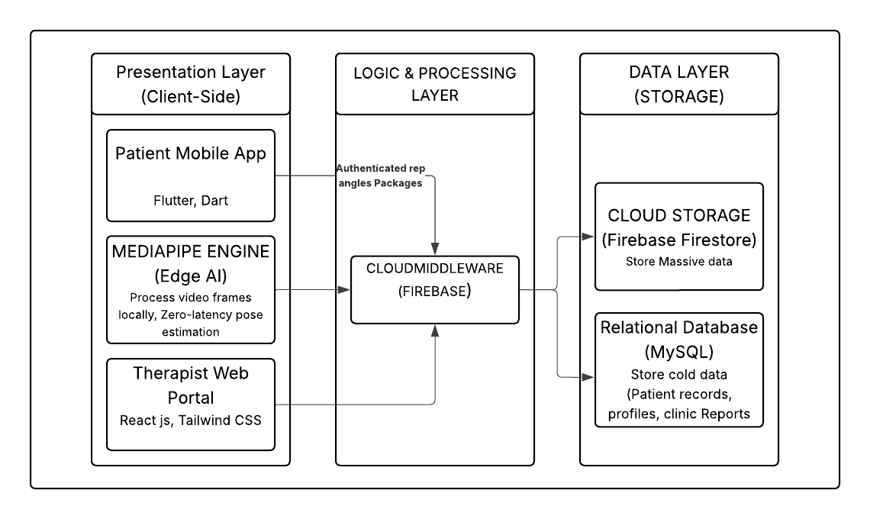
2.1.1 SOFTWARE ARCHITECTURE
In terms of architecture, a modified client-server architecture approach is utilized to ensure optimal performance while providing a centralized means for managing data. The proposed system utilizes edge computing whereby resource-intensive AI pose estimation is performed at the local level by the mobile device, providing zero latency feedback.

The architecture can be divided into three distinct layers:

1. Presentation Layer (Client-Side)
This layer takes care of user interface and user experience. The presentation will be twofold:

- Mobile Application (Flutter): Patient-facing. It takes care of live camera feeds and provides real-time visual/auditory feedback.

- Web Dashboard (React.js): Therapist-facing. Primarily concerned with data visualization, charts, and patient management.

- Technologies: Flutter (Dart), React.js, Tailwind CSS.

2. Logic & Processing Layer (Middleware)
This is the "brain" part of the system, in which data is converted into meaningful information. The system comprises two important sub-parts:

- Edge AI Engine (MediaPipe): Within the mobile application, the video frames are analyzed to detect 33 body landmarks and measure joint angles. Everything is done without uploading raw videos to the cloud; hence, the process is quick and private.

- Server-Side Logic (Laravel): This is where business rules are implemented for user authentication, distribution of exercise prescription, and generation of reports.

- Technologies: MediaPipe Framework, Laravel (PHP), RESTful APIs.

3. Data Layer (Storage)
This layer is responsible for the persistence and synchronization of all system information.

- Real-Time Database (Firebase): Handles "hot" data that needs immediate synchronization, such as live session logs and compliance streaks.

- Relational Database (MySQL): It deals with "cold" or structured data, such as clinical records, therapist credentials, and historical recovery trends.

- Technologies: Google Cloud Firestore, MySQL.

2.1.2 BLOCK DIAGRAM
Level 0 DFD (Context Diagram)

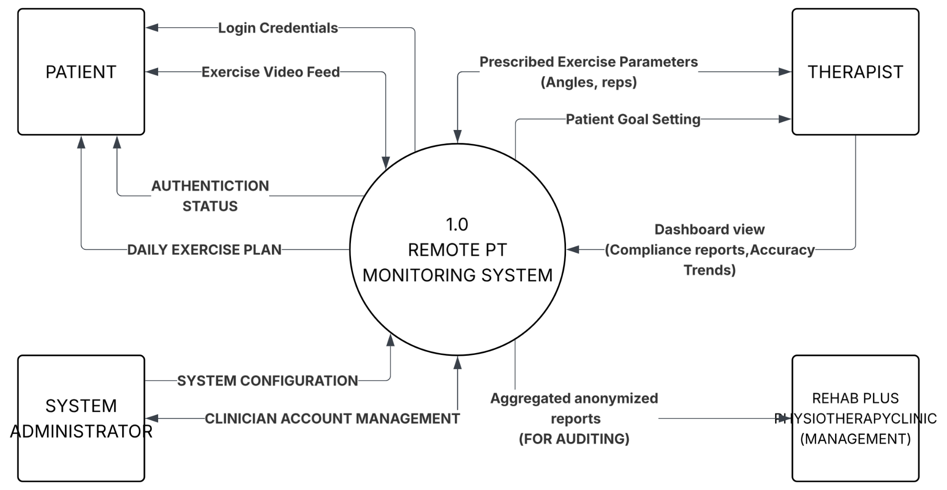
The Context Diagram shows the system at its highest level in its environment, with a single high-level process named "Remote PT System" and interactions with two primary outside entities, the Patient and the Therapist.

Level 1 DFD

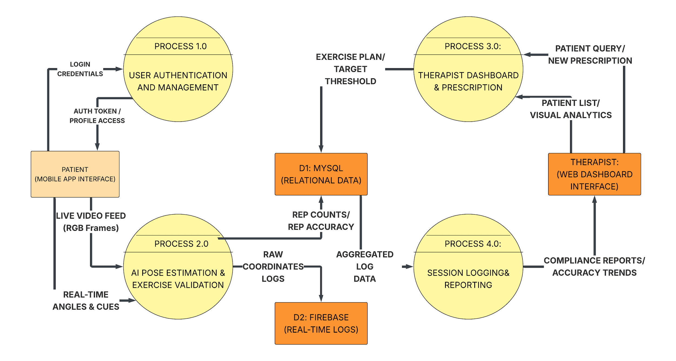
This Level 1 diagram shows the main functional subprocesses of the system. For the first time, a distinction between mobile/edge processing and cloud/web-based data management is identified at this level. What is depicted also, is the process taking place of converting raw motion data into compliance reports.

Level 2 DFD (Focus on Pose Estimation & Validation) -last
This Level 2 Diagram illustrates in more detail its central innovation: Process 1.2 (Process Live Pose Estimation) and Process 1.3 (Validate Repetitions). It discriminates how the MediaPipe landmark data interacts with the clinical thresholds established by Rehab Plus to inform real-time feedback.
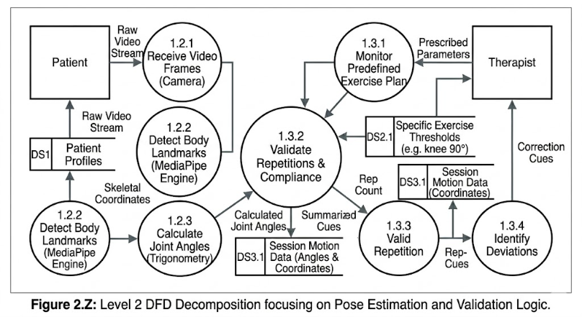

2.1.5 TEST PROCEDURES
To ensure the reliability and clinical viability of the Mobile-Based Camera-Assisted Remote Physical Therapy Monitoring System, a structured testing methodology is provided. The testing procedure will be structured across four major phases:

1. Unit Testing (Component Validation)

- AI Engine Test: Determines whether MediaPipe can correctly identify 33 body landmarks in different lighting conditions.

- Algorithm Test: Injects "mock" joint coordinates to test if the mathematical logic will correctly compute angles (e.g. a right angle will be read consistently as 90°).

- Database Test: Tests that the Laravel API can write a test record to the MySQL database.

2. Integration Testing (System Connectivity)This phase tests the interaction between different software components.

- Mobile-to-Cloud Sync: A validated repetition on the mobile "edge" should package the data, successfully send it to Firebase, and subsequently find it on the Web Dashboard.

- Auth Integration: The patient account created on the Web Dashboard should log in via the Mobile App.

3. Accuracy & Calibration Testing (The "Gold Standard" Test)

- Procedure: One proponent or test subject performs an exercise while a physical therapist measures the joint angle with a manual Goniometer (a physical tool used in clinics).

4. User Acceptance Testing

- Patient Testing: A patient is followed in using the application, setting up the camera, and following the correctional cues without any technical assistance.

- Therapist Testing: To ensure the Rehab Plus staff do not have any difficulties interpreting the "Accuracy Trend" charts and modifying the exercise prescriptions.

2.1.3 SOFTWARE DEVELOPMENT LIFE CYCLE (SDLC)

The proponents utilized the Waterfall Model with Iterative Feedback to ensure that every phase of establishing the "Mobile-Based Camera-Assisted Remote Physical Therapy Monitoring System" was documented and validated before the move to the next phase while allowing for refinements in AI logic.

- Planning - During this stage, the proponents established the boundaries of the project. They focused on rehabilitating Rehab Plus Physiotherapy patients. The team performed a feasibility test to ascertain whether the phone camera and MediaPipe could substitute the expensive clinical sensors. Relevant resources such as Google Cloud Console and development hardware were assigned.

- Analysis - The proponents obtained specific requirements from the physical therapists. They outlined the important exercises (for example, knee extension) and Joint Angle Thresholds. The proponents reviewed the existing manual system, which is paper-based home logs. They identified the "supervisory gap" that the AI system must address.

- Design - A three-tiered system architecture was developed during this stage. This process entailed the creation of the DFD and System Flowchart as discussed above. The proponents created the UI/UX mockup for both the mobile application (patient side) and website dashboard (therapist side).
- Development - This stage involves coding done by the proponents and includes:Mobile: Developed with Flutter and using the MediaPipe plugin for real-time skeletal detection.Back-end: Created using Laravel to manage the RESTful APIs and Firebase to synchronize the data in real time.Web: Developed with React.js to present the graphs for accuracy and log the compliance reports.
- Testing - As part of our testing protocol, we have subjected our system to several tests:Unit Testing: To test the angle calculating algorithmIntegration Testing: To test the mobile-to-web data synchronizationAccuracy Testing: To compare the results produced by the AI algorithm to a manual goniometer to verify if there is no greater than ± 3°-5°.
- Deployment - We have deployed our mobile application using an APK while the Web Dashboard is running on a live server. Our system was rolled out to a group of patients at Rehab Plus Physiotherapy.
- Maintenance - In order to fix any bugs after launch, the proponents will monitor the AI to see how it works in other mobile hardware and in varying lighting conditions. Updates will be uploaded to improve accuracy and increase types of exercises.

2.1.4 SYSTEM FLOWCHART

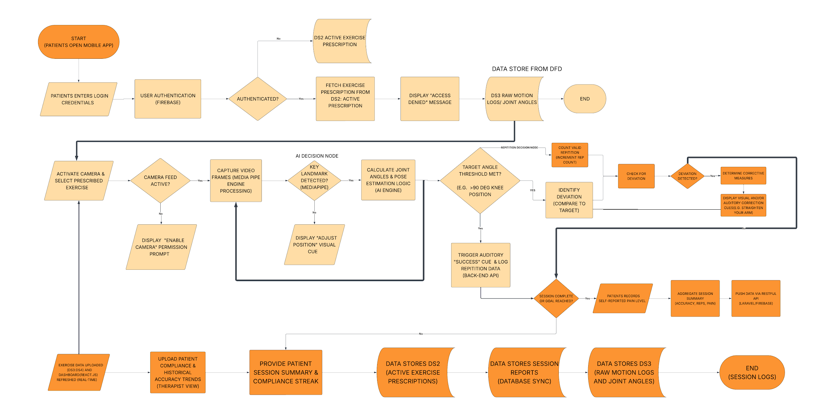

2.1.5 ENTITY-RELATIONSHIP DIAGRAM

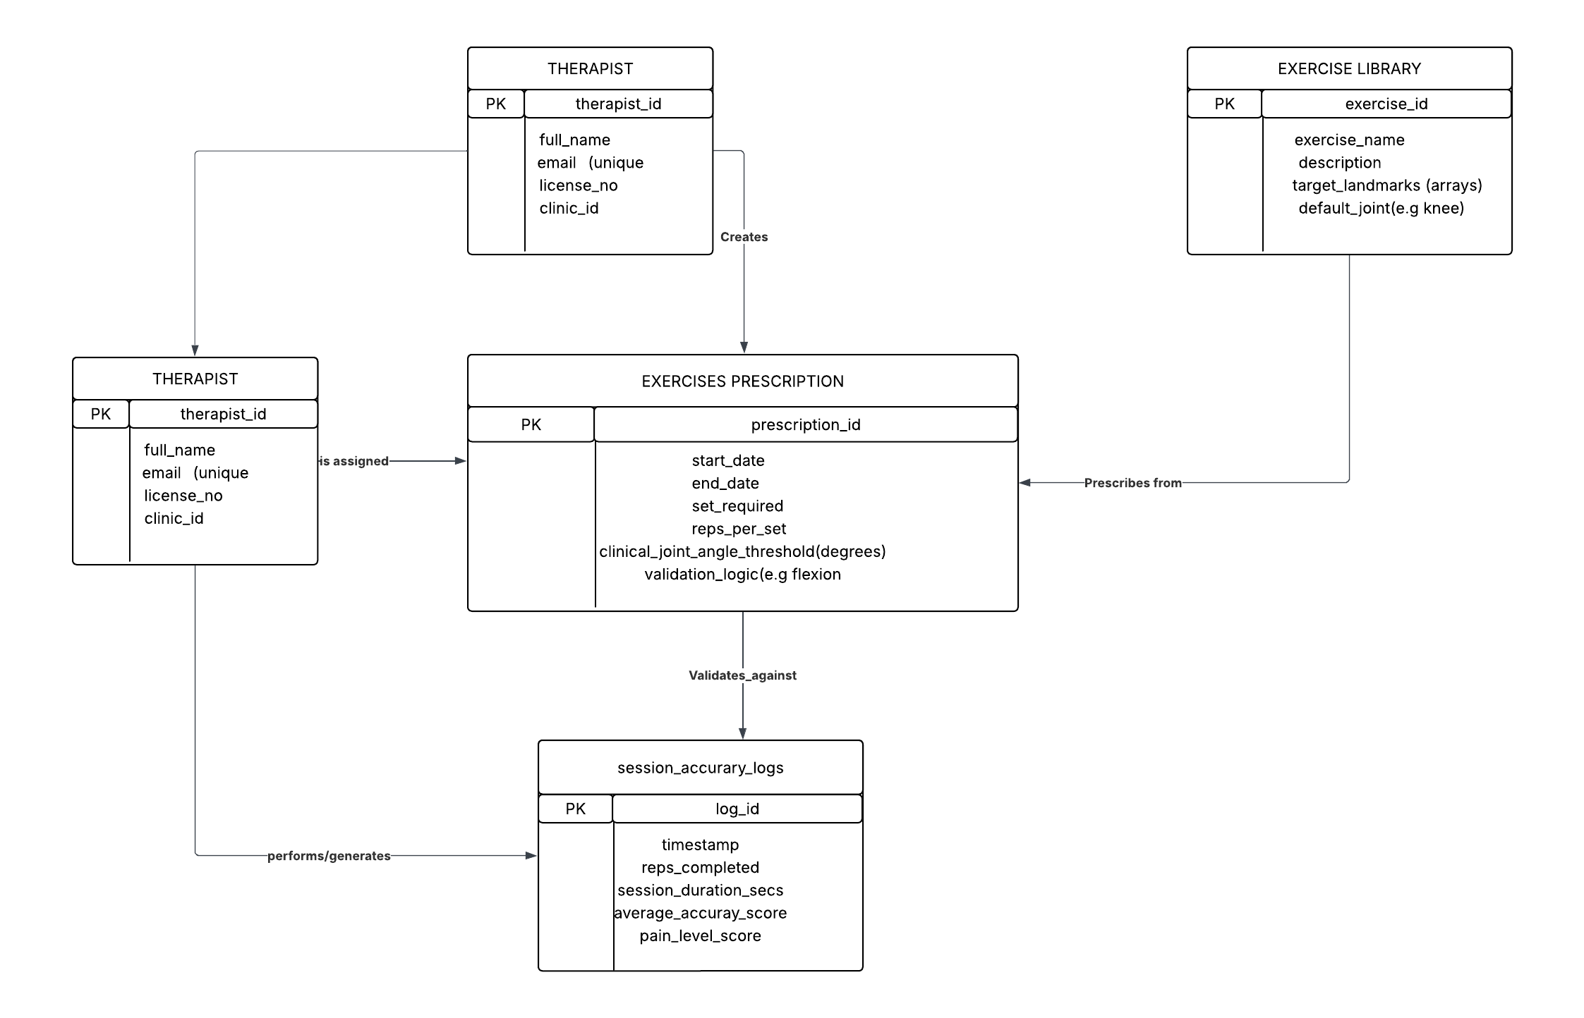

2.1.6 USE CASE DIAGRAM
The Use Case diagram shows how the interactions happen between the system’s key stakeholders and the services that the system can perform. For the Remote Physical Therapy Monitoring System, the key stakeholders include the Patient (Mobile App user) and the Physical Therapist (Web Dashboard user). The key services to be performed inside the system boundaries relate to AI validation and data reporting.

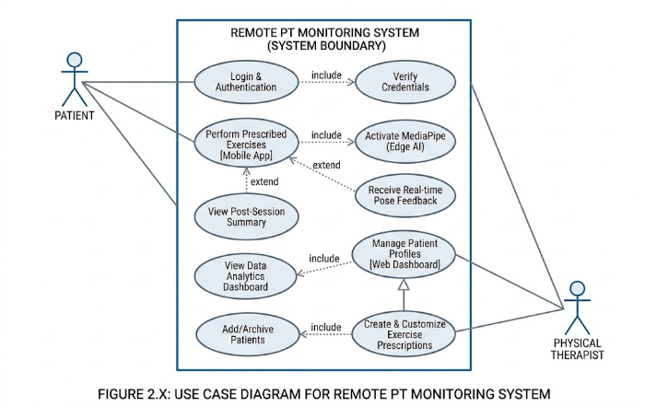

Use Case Description (Write-Up)

Based on the input methodology's requirements, the detailed use case description for the main use cases is as follows:

UC-1: Login & Authentication
- Actors: Registered Patient, Physical Therapist

- Precondition: User Account must be present in the system's MySQL database.

- Normal Flow:

- The user starts the application (Patient Mobile App/AdminWeb Dashboard).
- The user enters login information.
- Application checks entered login information against the user profile.
- Access is granted and the system loads the user's main menu (Patient Home/Therapist Dashboard).

Alternative Flow (Exceptions):

- AF-1.1: Incorrect Credentials: If the login information does not match, "Incorrect Credentials" is displayed and access is denied.

- Post-condition: User is logged in and authenticated, prepared to use their personalized features.

UC-2: Execute Prescribed Exercises (Mobile Application)
- Actors: Registered Patient

- Prerequisites: The Patient is signed in; Exercise Prescription is assigned by the Therapist; mobile phone has enabled camera access permission.

- Flow:

- The patient selects "Start Prescribed Exercise" in the primary menu of the app.

- The system launches "Activate MediaPipe (Edge AI)" routine to recognize body keypoints.

- The patient executes the chosen exercise (such as Knee Extension) in the camera view.
- The edge intelligence algorithm evaluates each rep by analyzing whether the target joint angle reaches the clinical threshold.

- Once the prescription objective is achieved, the Patient taps "Complete Workout."

- The system displays the "Review Post-Workout Analysis."

Alternative Flows (Errors):

- AF-2.1 (Get Real-Time Form Correction): This UC elaborates on UC-2. In case the algorithm identifies any major deviation in technique or insufficient form during the movement execution, it immediately launches UC-4 (Real-Time Form Guidance).

- Postconditions: A workout record is created in the local database.

UC-3: Evaluate Compliance & Accuracy Trend Analysis (Web Dashboard)
- Actor(s): Physical Therapist

- Prerequisites: The Therapist logs in successfully; the Patient session data is transferred using RESTful API to Firebase/MySQL database.

Main Process:

- The Therapist picks a particular Patient from the list.

- The Therapist taps "View Data Analytics Dashboard."

- The system renders the dashboard that includes:

- Compliance Graph: Total number of assigned and completed sessions.

- Trend Graph for Accuracy: Graph depicting accuracy trend improvement percentage.

- The Therapist examines the information and makes a judgment about their recovery.

Alternate Process (Exceptional Flow):

- AF-3.1 (Lack of Session Data): In case there's no patient data recorded, the system shows "No Session Data Available."

- Postconditions: The Therapist obtains an objective perspective about the patient's performance history.

2.3 REQUIREMENTS DOCUMENTATION

The below mentioned System Requirements Specification (SRS) defines the functional and technical requirements for Mobile-Based Camera-Assisted Remote Physical Therapy Monitoring System.
It acts as a blueprint to avoid any miscommunication and help design the project in accordance with clinical standards.

2.3.1 System Overview
The system is a multiplatform telerehabilitation solution which consists of a cross-platform mobile application for patients and web based management dashboard for therapists. The MediaPipe framework for edge-based pose estimation enables the provision of real-time corrective feedback for the execution of orthopedic exercises.

2.3.2 Functional Requirements Summary
- Movement Detection via AI: Continuous identification of skeletal landmarks and estimation of joint angles.

- Rep Counter Automation: Verification of repetitions according to clinical standards established by the therapist.

- Biofeedback for Correction: Instant auditory and visual feedback for proper form correction.

- Clinical Dashboard Management: Centralized interface for monitoring patient compliance, accuracy, and level of pain.

- Cloud Integration: Continuous synchronization of data between mobile and web-based systems.

2.3.3 Non-functional Requirements Summary
- Performance: Latency in AI analysis should not exceed 200 milliseconds.

- Reliability: System uptime must be kept at 99.9% for clinic availability.

- Security: Data encryption and multi-factor authentication for therapists.

- Usability: Design focused on accommodating users with mobility issues.

2.3.4 Constraints and Assumptions
- Hardware Assumptions: The system will assume the presence of a smartphone with a 12MP camera and adequate processing capabilities to operate the MediaPipe engine.

- Environmental Variables: Accuracy is based on ideal lighting conditions and clarity of the patient's body or individual limb segments.

- Internet Connection: It is presumed that patients possess a reliable internet connection for initial data synchronization and dashboard management.

- User Compliance: The system presumes that patients have undergone an initial face-to-face evaluation by a professional therapist before engaging in remote therapy sessions.

2.3.5 Glossary of Terms

- MediaPipe: Open-source toolkit from Google that provides an architecture for constructing multimodal applied machine learning pipelines.

- Joint Angle Threshold: The particular angle through which a joint must move in order to be considered clinically significant.

- Edge Computing: Computation performed on the device itself to reduce latency time rather than relying on cloud computation.

- Recall Bias: Error resulting from the inconsistency between the information recalled by study subjects (e.g., using paper logs).

2.4 Development and Pre-testing Procedures
This part presents the technical implementation and quality assurance measures undertaken by the proponents. In addition, this section discusses the particular set of tools that the team implemented to integrate AI pose estimation and clinical reporting.

2.4.1 Development
The proponents' development process concentrated on creating a highly performant, real-time system that will allow for implementing computer vision tasks on mobile phones while having central web monitoring control.

Development Environment and Tools:

- Integrated Development Environment (IDE): The proponents made use of Visual Studio Code (VS Code), which has excellent performance characteristics, including a wide range of Flutter and PHP/Laravel IDE plugins.

- Source Code Management and Versioning: For source code management, the proponents chose Git, with GitHub providing cloud-based hosting for version control systems.

- API Testing: Postman was used to test and verify the RESTful APIs prior to integrating them within the mobile application.

Programming Language and Frameworks:
- Mobile Application: The proponents used Dart and the Flutter framework for developing the mobile app.

- Back-end API: Constructed through PHP programming language using the Laravel framework for secure data routing and business logic implementation.

- Artificial Intelligence Engine: The MediaPipe framework was embedded through Flutter plugins, enabling edge computing-based and real-time skeletal tracking and landmark detection.

Database Management Systems:

- MySQL: Chosen as the main relational database management system for storing clinical structured data, user details, and therapist authentication information.

- Firebase/Cloud Firestore: Employed as additional databases for the synchronization of real-time movement coordinate data and accuracy logs.

Methodology Used:

- The proponents utilized the Iterative Waterfall Model in this project. Through this methodology, the team was able to undertake architectural design prior to coding; however, there is still an opportunity to conduct iterative sprints for fine-tuning of the landmark detection algorithm sensitivity by developers.

2.4.2 Pre-testing
In order to guarantee the stability of the system prior to its launch within Rehab Plus Physiotherapy, the proponents conducted certain tests internally.

- Unit Testing: Each module of the software, for example, Angle Calculation Algorithm and Authentication Module, was tested individually. As an illustration, calculations of angles of joints performed using trigonometry were confirmed through using static coordinates.

- Integration Testing: The proponents tested the communication between Mobile App and Web Dashboard. In particular, they made sure that each session’s summary sent through the mobile phone updates the database in a correct way, and is displayed accurately on the therapist’s chart.

- Alpha Testing: It was conducted internally by the proponents. Members of the team played the role of patients, trying out the application under various lighting conditions and backdrops in order to detect those situations when the camera may fail to recognize certain body landmarks.

- Debugging and Revisions: Every discovered
- bug – be it interface overflows, connection-timeouts, or even “flickering” from AI – was tracked via a bug-tracker software. Afterwards, code revisions were undertaken followed by module testing, until the desired performance level, which was < 200ms latency, was achieved.

2.5 Implementation Plan
Includes the description of the particular technical specifications and rollout strategies that will be used to move the software from the development environment to the production environment in the form of its deployment at Rehab Plus Physiotherapy.

2.5.1 System Requirements
To guarantee high-fidelity execution of the MediaPipe AI engine and real-time data synchronization, the following system specifications should be met:

Hardware Requirements:

- On the client side for patients: a smartphone with at least 4 GB RAM and HD camera (1080p).

- On the client side for therapists: a computer with at least 8 GB RAM and a contemporary processor such as Core i3.

- On the server side: cloud servers of AWS (Amazon Web Services).

Software Requirements:

- Mobile operating system – Android 9.0 (Pie) and later or iOS 12.0 and later.

- Web browser – latest version of Google Chrome, Mozilla Firefox, Microsoft Edge for accessing the Therapist Dashboard.

- Server Environment – Linux-based (Ubuntu) with an Nginx, Apache web server or Windows server.

Network Requirements:

- An internet connection with speed not less than 5 Mbps is needed to enable real-time synchronization between mobile and cloud-based environments.

2.5.2 Deployment Strategy
The proponents will adopt a Cloud Hosting Deployment strategy to ensure that the system is accessible to patients located in distant areas.

Steps for Deployment:

- Back-end Hosting: Laravel API and MySQL database will be deployed using AWS EC2 and RDS services.

- Front-end Hosting: React.js Dashboard will be deployed on Vercel or AWS Amplify platforms.

- App Deployment: The mobile app will be first deployed via an Over-The-Air APK deployment method in its early stages.

Training of Users:

- Training of Therapists: One day training at the Rehab Plus facility to show them how to set up "Clinical Thresholds" and interpret "Accuracy Trend Charts."

- Training of Patients: In-app tutorial to guide patients on setting the position of their cameras to meet the visibility requirements of the AI system.

Deployment Phases:

- Phase 1 (Alpha): Deployment and testing phase by proponents (2 weeks).

- Phase 2 (Beta): Deployment for pilot study involving 5 patients and 2 therapists (3 weeks).

- Phase 3 (Full Deployment): Complete deployment to all patients in the database of the clinic.
2.6 Statistical Treatment of Data
2.6.1 Data Gathering
To ensure ISO/IEC compliance of SARGO, an interview will be conducted with the staff and managers or “Rehab Plus Physiotherapy”, along with a survey. Additionally, a separate survey will be conducted with the customers of “Rehab Plus Physiotherapy”.
Sampling method
Non-probability sampling techniques will be utilized in this study, specifically purposive sampling (also referred to as judgmental sampling). The rationale behind this sampling design is the fact that the developers have deliberately chosen the respondents that are responsible for using this system to determine its usability, accuracy, and reliability. The relevance of choosing orthopedic patients and professional physical therapists ensures that the obtained results reflect the practical performance of the system in the medical environment.

By using this technique, the evaluators can become competent enough to give an adequate opinion regarding the AI’s ability to estimate poses and usefulness of the dashboard.

The supporters will conduct this study using the method of Purposive Sampling (also called judgemental or subjective sampling). The non-probability sampling technique was chosen since this type of study needs an exact set of people such as orthopedic patients and clinical personnel rather than a random sample of the general public.

Data Evaluation
In all, forty-three (43) participants would be chosen to take part in this research. The participants will be the users/clients and IT specialists. In this study, the users are categorized into two categories. On one hand, we have the physical therapists from the physiotherapy clinic named Rehab Plus Physiotherapy who would assess the clinical dashboard and administrative interface and, on the other hand, patients receiving orthopedic rehabilitation who would be able to evaluate the mobile application interface. This is done in order to ensure that the feedback received from the participants would help in the evaluation of the data gathered which could then contribute to enhancing the system's functionality.

Scale Ratings
A survey would then be undertaken to determine how functional the Remote Physical Therapy Monitoring System is. The survey would include the patients, the clinical personnel, and the IT professionals involved in this study. Each person would have his/her own focus area concerning the system, but the rating scales for all participants will remain the same.

- 5-point Likert-type Numerical Rating Scale
This type of scale ratings would be utilized throughout the entire study because it gauges the extent to which the users find this system to be satisfactory and functional.

Example:
Statement: Features or quality of the Remote PT System:
(5) Excellent
(4) Very Good
(3) Good
(2) Fair
(1) Poor

Percentage and Frequency Analysis
Calculations of the responses will be done to come up with the results of the survey. The calculation will take into account percentage distribution to find out the overall scale for each criterion in the survey based on the ISO/IEC 9126 software quality characteristics.
2.6.2 Settings of the study
The experimental study was done at Rehab Plus Physiotherapy and Sports Clinic which is situated on the 2nd floor of the Health and Wellness Center in Diliman, Quezon City, Metro Manila. This place became the main center for conducting our study since it had all the conditions needed for implementing and testing the created monitoring system. The choice of this particular facility was due to several difficulties faced by the head physical therapist and staff at the clinic that required improvement of the remote monitoring procedure.

The specialty of the organization called Rehab Plus is that it is an orthopedic rehabilitation center where people suffering from musculoskeletal injuries can undergo treatment. The company includes a total of five (5) Physical Therapists and two (2) administrative employees that monitor daily performance and session of patients. This facility provided us with a possibility to conduct testing procedures using the developed algorithm.

2.6.3 Subjects
In this case, the main objective of the study revolves around improving the process of working with the clinic in relation to the workflow. This involves the head therapist and the clinicians at Rehab Plus who are responsible for monitoring the recovery exercises of the patients. The process will not require any form of human interference in terms of repetitive monitoring of the exercise routine, measuring angles, and recording of the sessions. In addition, another group of end users includes the patients at the Rehab Plus who are required to conduct their own routine exercises and follow the instructions provided by the AI.
2.6.4 Sampling Technique
A purposive sampling method will be used in assessing the effectiveness of the system. The sample consisted of the head physiotherapist, clinicians from the institution, and selected patients who had been taking part in orthopedic rehabilitation at the facility. The method was considered effective as it allowed the researchers to identify persons who had the necessary skills and competencies in providing feedback about the effectiveness and efficiency of the system.

The head physiotherapist and clinical staff were considered important participants as they had direct knowledge of exercise prescription and were able to check the effectiveness of the AI's accuracy compared to a standard goniometer. At the same time, patients undergoing treatment were asked to fill out evaluation forms in order to provide feedback regarding the user interface and live assistance provided by the app.

2.6.5 Statistical Treatment of data
Common treatments:
- Weighted Mean — Average score per criterion to determine overall system quality.
Likert Scale Interpretation:

- 4.50–5.00 → Strongly Agree
- 3.50–4.49 → Agree
- 2.50–3.49 → Neutral
- 1.50–2.49 → Disagree
- 1.00–1.49 → Strongly Disagree

